DG-5

*by* Vamshikrishna Namani

**Submission date:** 11-Mar-2023 02:47PM (UTC+1000)

**Submission ID:** 2034488044

**File name:** Article-1.pdf (264.98K)

**Word count:** 1651

**Character count:** 8850

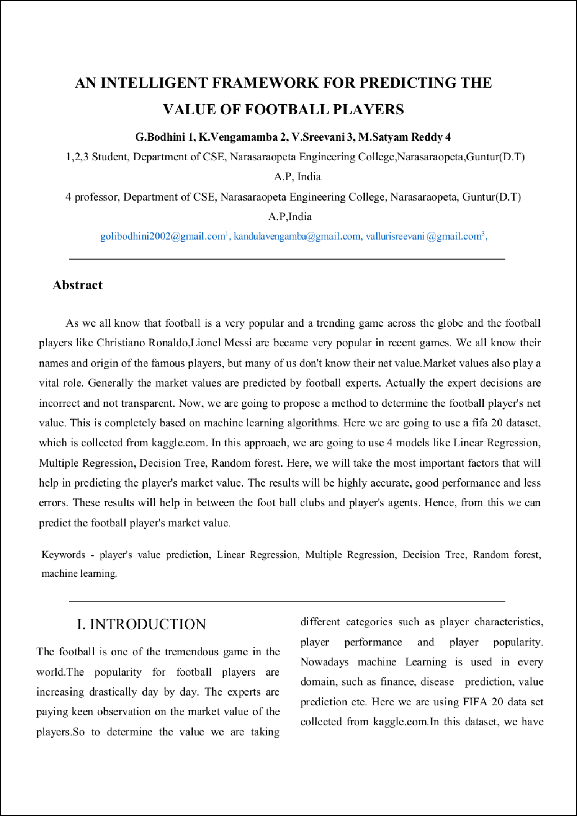

2

2

1

1

1

1

1

1

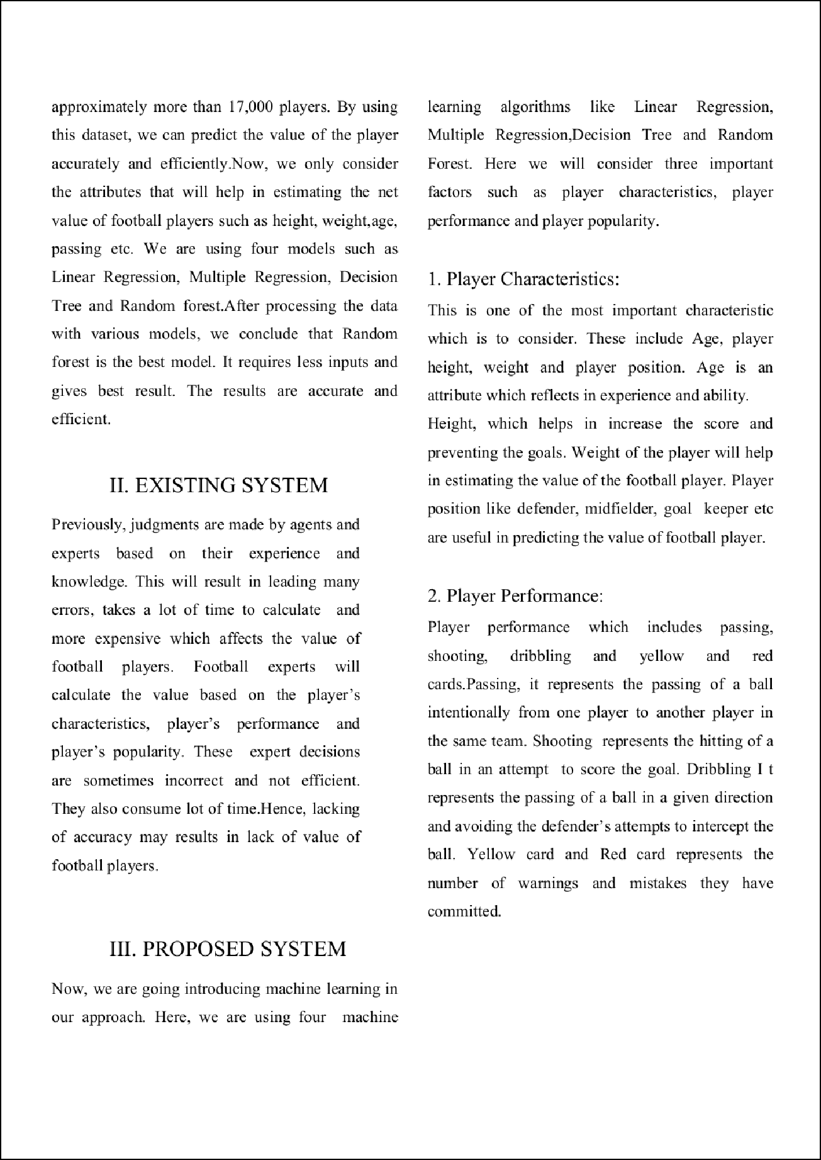

1

1 1

1

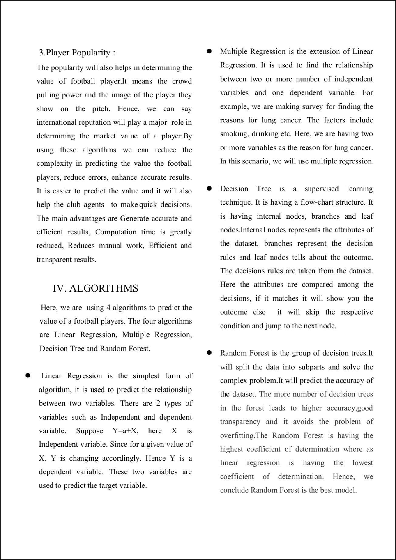

5

4

1

1

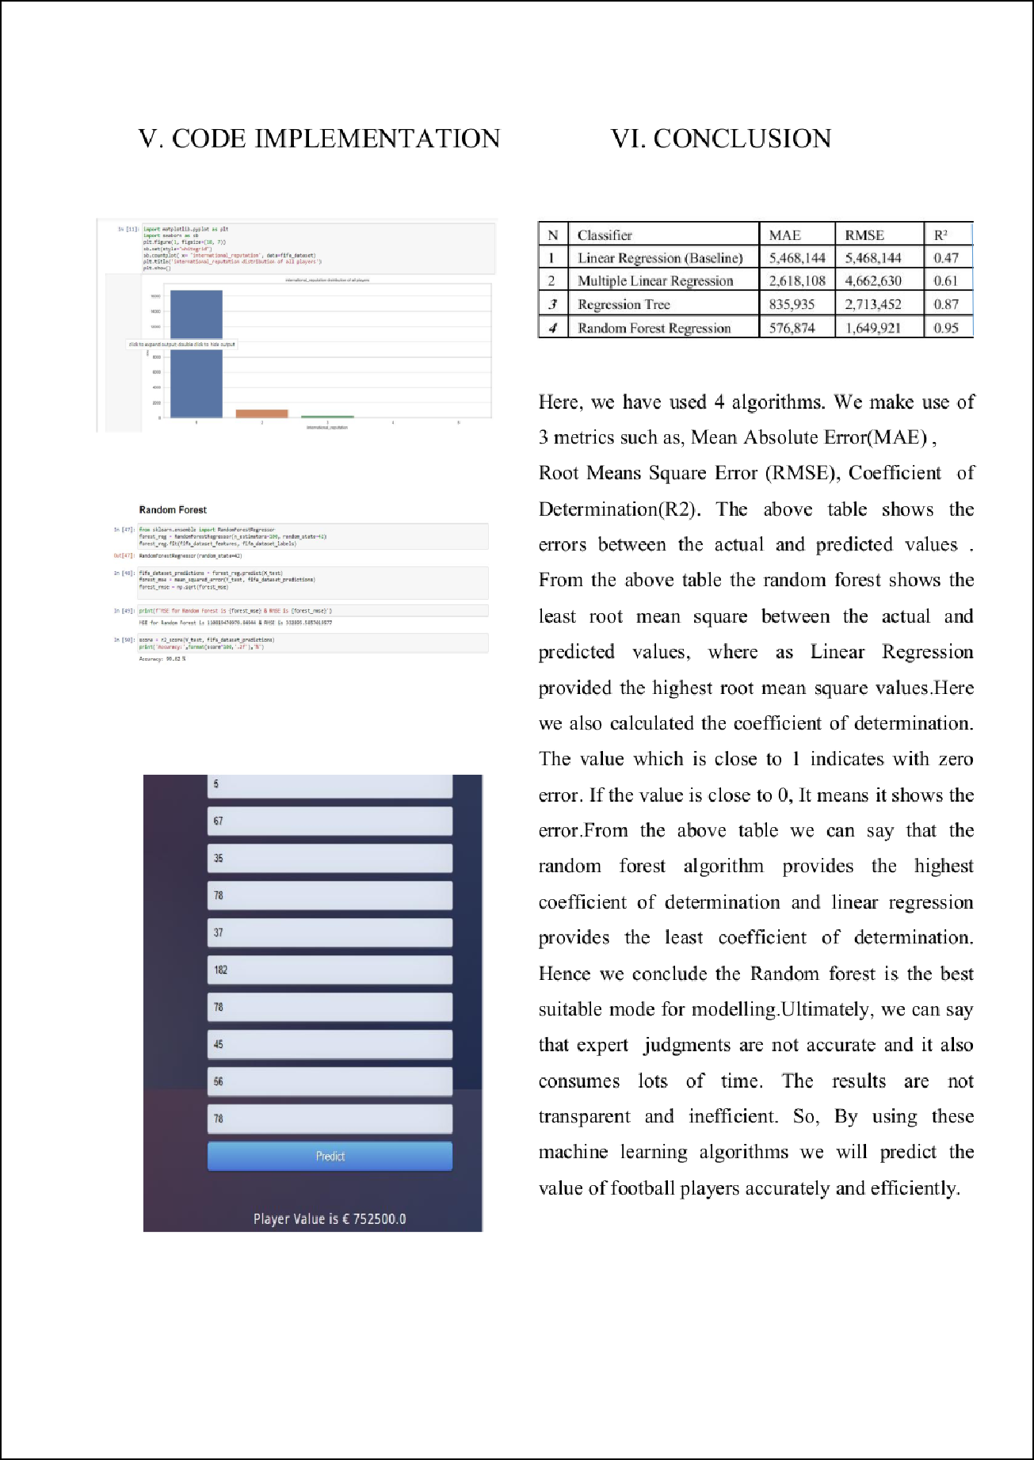

3

1

1

6

1

1

1

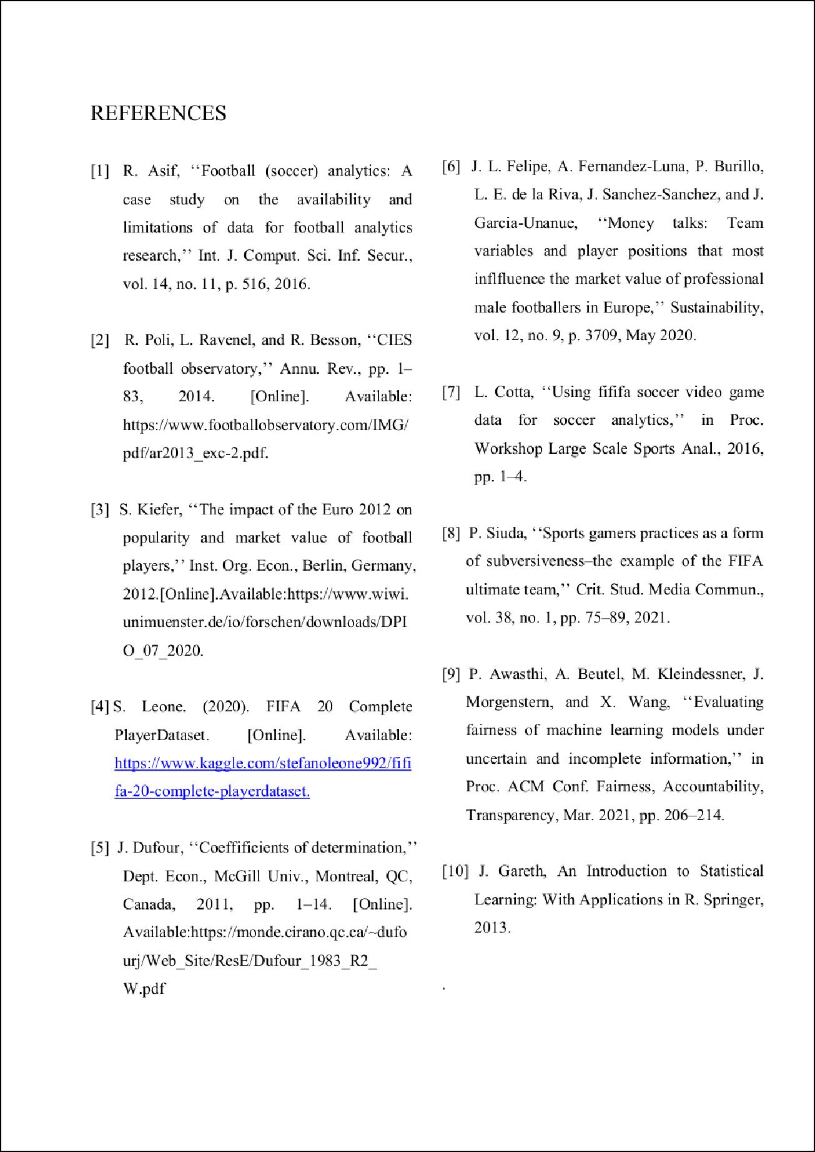



DG-5

ORIGINALITY REPORT

14

%

SIMILARITY INDEX

2%

INTERNET SOURCES

13%

PUBLICATIONS

2%

STUDENT PAPERS

PRIMARY SOURCES

1 Mustafa A. AL-ASADI, Sakir Tasdemir. "Predict the Value of Football Players Using FIFA video game data and Machine Learning Techniques", IEEE Access, 2022

Publication

2 S. Siva Sunayna, S. N. Thirumala Rao, M. Sireesha. "Chapter 25 Performance Evaluation of Machine Learning Algorithms to Predict Breast Cancer", Springer Science and Business Media LLC, 2022

Publication

[www.researchgate.net](http://www.researchgate.net/)

3

Internet Source

4 "Proceedings of Second International Conference on Advances in Computer Engineering and Communication Systems", Springer Science and Business Media LLC, 2022

Publication

yorkspace.library.yorku.ca

5

Internet Source

10%

1%

1%

1%

1%

www2.mdpi.com

6

1

Internet Source %

Exclude quotes On Exclude bibliography On

Exclude matches Oﬀ